Moore Place Afternoon Menu
available 2pm to 6pm
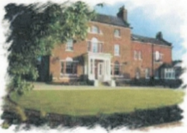

Tea £3.00
English Breakfast, Camomile, Green, Earl Grey, Peppermint

Freshly Brewed Coffee
Americano, Latte, Cappuccino, Flat White £3.70
Macchiato, Expresso £2.70
Sandwiches White, brown or gluten free bread
Smoked Salmon £10.00
Cheese and pickle £8.00
Ham and Cheese £8.00
Ham and Tomato £8.00

Pizza Authentic Italian pizza (10 inch)
Pepperoni - cheese, tomato and pepperoni £16.50
Margherita - cheese and tomato £14.50
Veggie Supreme – cheese, tomato, red onion,
pepper, mushroom, sweetcorn £17.50

Dessert
Banoffee Cheesecake (vegan) £8.50
Chocolate Fondant (gluten free) £8.50
Apple Tarte Tatin £8.50
Lemon Tart with raspberry coulis, whipped cream £7.50
Ice Cream Selection (2 scoops) £5.50

