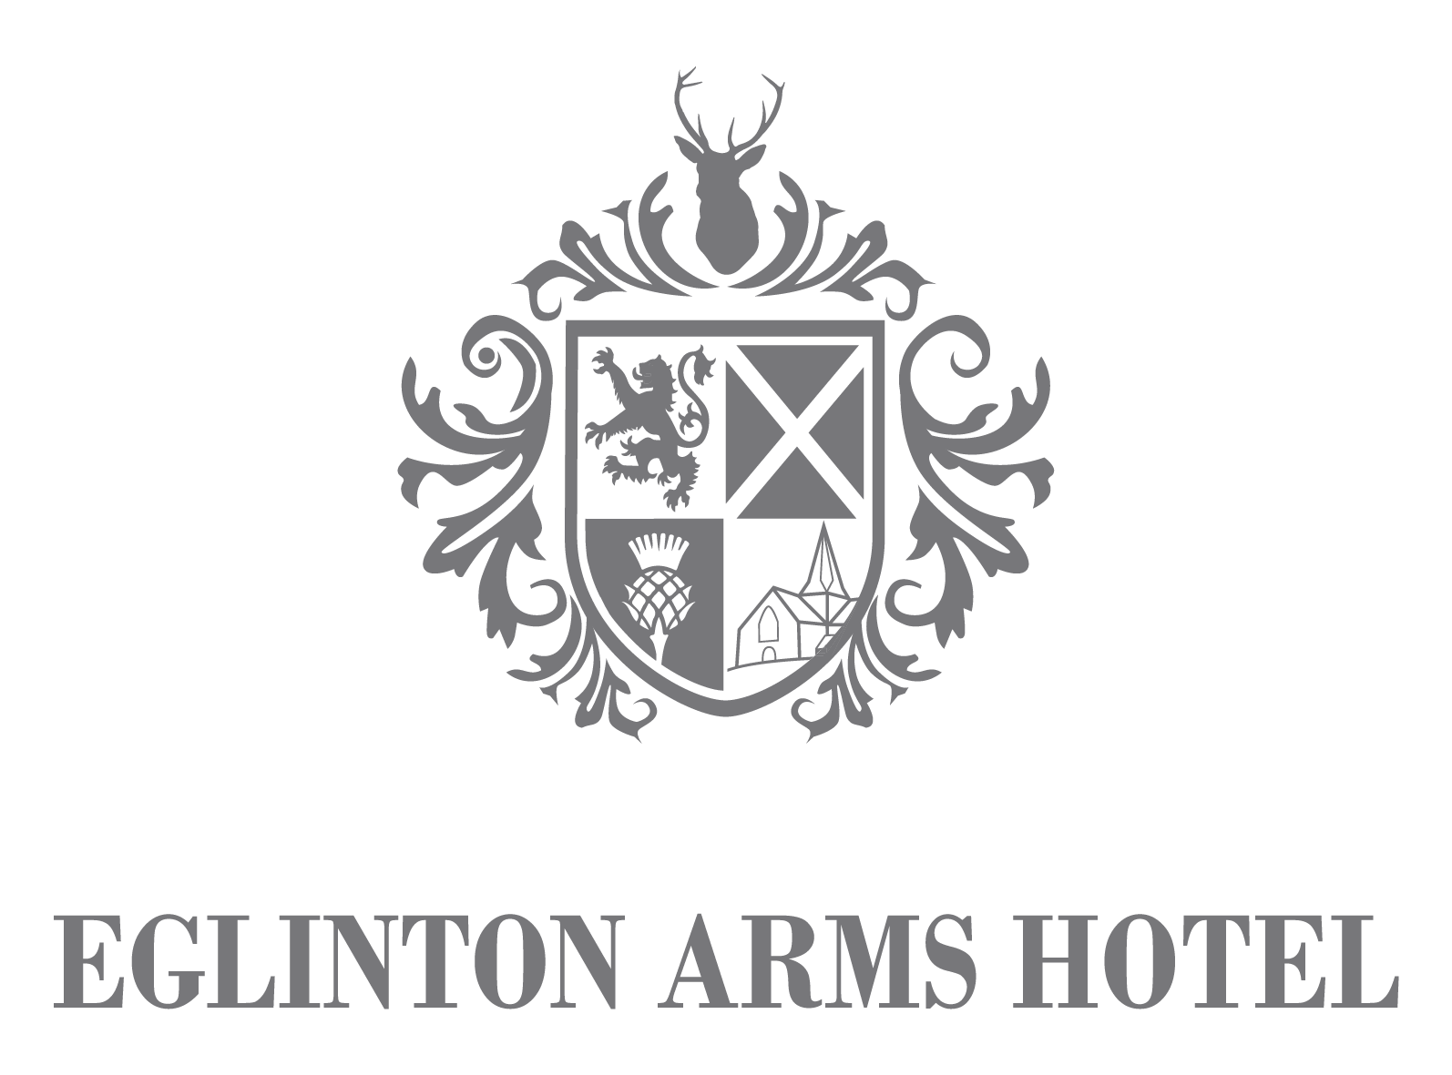

Sample Special Occasion Menu

£27.00 3-courses & coffee

Menu can be personalised

and photograph added

To Begin

**CHICKEN LIVER PARFAIT**

highland oatcakes & caramelised onion chutney

**SOUP OF THE DAY**

served with a bread roll (v)

**HAGGIS, NEEPS & TATTIES**

peppercorn sauce

**CHEF’S VEGETABLE PAKORA**

tomato & mint dip

The Main Event

**CHICKEN ESCALOPE**

sarladaise potato, cabbage, smoked bacon & red wine jus

**STEAK & GUINNESS PIE**

honey roast vegetables & potatoes

**BUTTERNUT SQUASH & SWEET POTATO MASALA**

spiced yellow rice & naan bread

**SEARED SEABREAM**

coccote potatoes, roasted baby shallots, confit garlic & parsley broth

Something Sweet

**WARM CHOCOLATE BROWNIE**

chocolate sauce & vanilla ice cream

**MARSHMALLOW CHEESECAKE**

candy floss

**WARM STICKY TOFFEE PUDDING**

butterscotch sauce, vanilla ice cream

**TRIO OF AWARD-WINNING LANARK ICE CREAM**

crushed meringue & berries

**Tea or coffee**

Any guest who suffers from any known allergens or intolerances should inform the staff. We cannot guarantee our produce is 100% free from allergens/intolerances. Please advise your server of any special dietary requests.

Updated October 2023

EGLINTON ARMS HOTEL

